 | 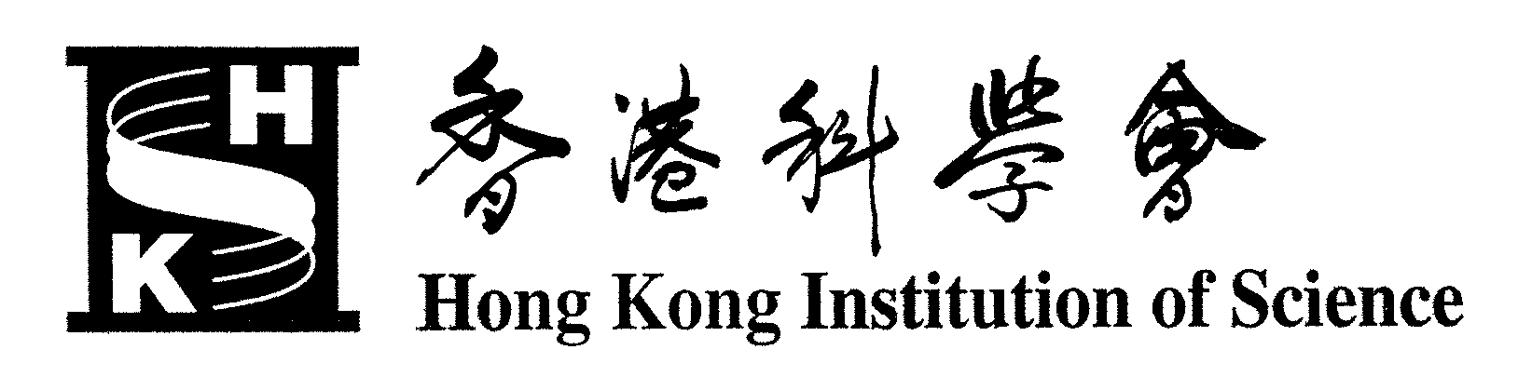  Hong Kong Institution of Science

2004 YOUNG SCIENTIST AWARDS

Objective

To reward young scientists and engineers in Hong Kong who show great promise in their field of study, with the hope that this will nurture the growth of science and technology in the region.

The Awards

Three awards will be given annually at the HKIS Annual Meeting (usually held in November), one in each of the following fields:
(a) Physical / Mathematical science
(b) Life science
(c) Engineering science
Each award carries a cash prize of $10,000 and a certificate of recognition. In addition, a plaque of recognition will also be given to the recipient’s supervisor.

Eligibility

All postgraduate research students who are pursuing an M.Phil, M.D.(Doctor of Medicine) or a Ph.D. degree in any of the tertiary institutions in Hong Kong. Students who have graduated recently (within 2 years of graduation) are also eligible.

Selection Criteria

Evidence of research excellence in science or technology and the potential to become a good scientist or engineer is sought. Screening will first be made of papers submitted describing the applicant’s respective work, and short-listed applicants will be asked to give an oral presentation of their work for the final selection.
A separate Selection Panel for each of the 3 fields will review the applications.

Submission

Applicants are required to submit the following:
(1) The Application Form (soft copy and hard copy), duly completed and signed, including an extended summary of the work (about 1,000 words) and a statement highlighting the significance of the work.
(2) A paper (or a number of related papers) or a patent describing the work pursued. Preferably, the paper has been published, or accepted to be published, by an internationally-referred journal. The applicant needs not be the first author of the paper but, obviously, priority counts and the applicant needs to specify (in the Application Form) the level of his or her contribution to the published work.
(3) A letter of endorsement from the applicant’s supervisor(s) of the submitted work.

Please send the soft copy of the Application Form to: ksleung@fehd.gov.hk, and
the hard copy of the above (1)-(3) to: Dr. K.S. Leung
Food Research Laboratory
4/F Public Health Laboratory Centre,
382 Nam Cheong Street, Kowloon.
All submissions should reach Dr. K.S. Leung, Hon. Secretary on or before 15th July, 2004

Hong Kong Institution of Science
official use:

YOUNG SCIENTIST AWARDS
⎯ APPLICATION FORM ⎯

Name of applicant: (underline Surname) |  |  |  |  | in Chinese (as applicable)
Field of study: | Physical/Math science Life science Engineering science
Title of work:
Place where work is (was) performed: (specify Institution & Department)
Contribution to the work (%):
Supervisor of the work:
Degree for which the work is (was) performed:
Date of graduation:
Present place of work (if applicable):
Extended summary of the work (about 1,000 words)

List of relevant publications/patents

Statement highlighting the significance of the work

Applicant’s address: |  | Email:
Applicant’s address: |  | Tel:

Signature of applicant |  | Date

